公共管理国际会议论文排版要求及格式样张∗

1.LAN Hua 2.ZHAO Shu-rong

1 School of Management, Harbin Institute of Technology, P.R. China, 150001

2 School of Political Science and Public Administration, University of Electronic Science and Technology of China, Chengdu, P.R. China, 611731

摘要：这份说明给出了公共管理国际会议论文投稿的基本要求。向会议提交的论文为5-7页，且必须应用此格式，您可以到会议的网站上下载（www.icpa-uestc.cn）。摘要不得少于120个英文单词，关键词不得少于4个，用逗号隔开。每个关键词第一个单词的首字母大写，其余小写。
关键词：字体，格式，页边距

1 引言
请将您的论文用纸设置为210mm×297mm的A4纸，全篇论文请在“段落”选项中将“行距”设置为“单倍行距”，每段首行缩进2字符。一级标题要上空一行，二级标题不需要上空。所有的图形、表格和公式都必须包括在您的论文中，请不要链接到外部的文件。

2 方法论

2.1 格式
在“页面设置”的“页边距”选项中：“上”页边距设置为41mm，“下”页边距为41mm，“左右”页边距都为32mm，“距边界”中“页眉”设置13mm，“页脚”设置为20mm。“文档网格”选“无网格”。正文采用一栏式，在“格式”的“分栏”选项中，“栏数”设置为1。

2.2 字号大小和字体样式
请按照Tab.1中所注明的字体和字号大小进行排版，全篇论文选用Times New Roman字体，

Table 1 论文排版字体与字号大小一览表
字号  大小 | 字体样式
字号  大小 | Times New Roman | Times New Roman加粗
9 | 图、表格 | 图题、表题
10 | 正文、公式、参考文献  作者姓名  摘要  关键词  三级标题 | 二级标题
小四 |  | 一级标题
四号 |  | 论文题目

正文部分选用10号字。论文题目字体选Times New Roman加粗，字号为四号，其中每个实词的首字母大写；作者姓名选10号字，姓大写，名字的第一个单词首字母大写，名字之间用短线连
接，作者之间空两个空格，作者排名序号请用数字标在姓名前面；作者单位选10号字，单位前面加序号（假如作者都同在一个单位的，则在单位名称前不需加序号），后面请写“哪个城市的英文，P.R. China, 邮政编码”；一级标题和二级标题中第一个单词的首字母大写，其余小写，字体选Times New Roman加粗，一级标题选小四号字，加粗，二级标题选10号字，加粗。

3 结果
3.1表格和图
图和表格的文字请用小五号字，图题和表题请加粗，且第一个单词的首字母大写，其余小写。
表题与上面文字之间空一行，表题置于表格上方，用“Table”表示，如“Table 1”，文中需要提到该表时也请用“Table 1”。
请尽量采用Word中的绘图工具绘图，如果有些图无法用Word中的绘图工具绘制，请不要将图题放在您绘制的图中，必须用Word单独排版。为了保证您论文中图的清晰度，请不要用颜色和灰度图来区分图中的不同含义，因为是单色印刷，且灰度图印制出的效果非常不好，故建议不要采用。
图题应放在图的下方，用“Figure”表示图，如“Figure 1”，文中提到该图时也请用“Figure 1”，图题与下面文字之间空一行。

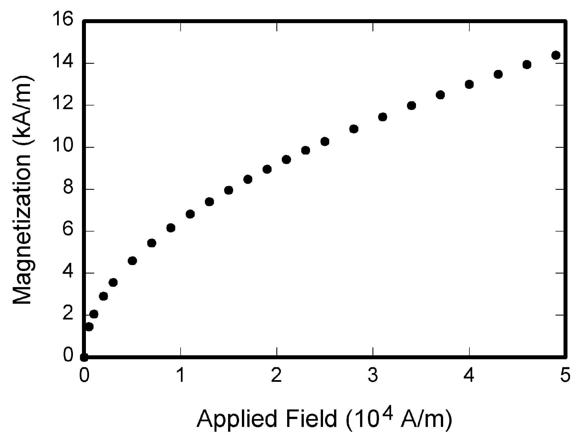

Figure1 Magnetization as a function of applied field

3.2 参考文献 （引用的参考文献不得少于8篇）
引用的参考文献应用连续的数字在方括号中标出，参考文献在文中用上角标标注，该句的标点符号跟在方括号之后，参考文献的顺序应按在文中出现的顺序排列。
请注意本说明最后的参考文献格式是标准格式，也是我们希望您能在论文中应用的格式。
除非作者人数在6人或6人以上，否则您应该列出所有作者的名字，而不能用“et al”代替。作者姓名起首的大写字母之间要用一个空格隔开，除专有名词和元素符号外，被引用文献的题目需第一个实词的首字母大写，其余小写。对于非英文参考文献，请用英文表示，然后在该文献题目之后用圆括号注明原语种,如(in Chinese)，(in Japanese)等等。

3.3 缩写
即使在摘要里已经进行了定义，当缩写词第一次在论文中出现时，应对其进行定义，但像IEEE、SI、MKS、CGS、ac、dc和rms之类的缩写就无需定义。由几个首字母合并起来并含有句点的缩写无需在句点和字母中间加空格，如：“C.N.R.S.”就不应写成“C. N. R. S.”。尽量避免在题目中出现缩写。

3.4 公式
公式排版请用公式编辑器编排，公式需要用圆括号加数字进行连续编号，并使编号与每栏的右边线对齐，参见(1)，如
A+B=C (1)
注意公式中的符号要事先定义或紧接在公式下给出定义。公式中的变量须用斜体。

3.5 其他
当小数点前的数字为零时，不要写“.25”而要写成“0.25”，“cm³”不要写成“cc”，表示样本面积时应使用“0.1 cm × 0.2 cm”，不要写成“0.1 × 0.2 cm²”。

4 结论
最后，您应该对您的语言负责，因为审稿专家和编辑们不会再对文章中的语言作核对和改动。当您完成论文时，请检查其中的拼写和语法，请尽量找一位专业的审稿人员帮您检查。
像“non”、“sub”、“micro”、“multi”和“ultra”之类的前缀不是独立的单词，它们应该与所修饰的单词一起使用，且不用连字符。
对于基金资助请放在第一页的脚注处, 并统一用格式“Financed by +资助项目”。也请您翻译准确资助的项目名称。（见首页格式）

格式范文：

Government Governance and Political Trust in Transition China:
An Empirical Analysis

MENG Tian-guang

School of Government, Peking University, Beijing, P.R. China, 100871

Abstract Recently, building a service-oriented government and pursuing good governance have become indispensable choices for Chinese government to promote socio-economic development. As the tie between individual citizen and various government institutions, political trust is not only regarded as an important indicator of political legitimacy embodying citizens’ support for government, but also treated as scarce resource which is helpful to enhance governance performance. Based on 2008 Chinese Public Attitudes towards Citizenship National Survey and relevant macro data, this paper tries to explore quantitatively the complex relationship between government governance and political trust in transition China, especially the effect of economic development, social welfare and pure public goods supply on political trust. OLS model shows that there is a significant relationship between the positive retrospective and prospective assessment of economic development, social welfare and public goods supply and high level of political trust, and yet retrospective assessments have more explanatory power than prospective ones. …………………………………………………………………………..
Key words Government governance, Political trust, Economic development, Social welfare, Pure public goods

1 Introduction
Since 21st century, Chinese government has been sparing no effort to build a harmonious society. The construction of service-oriented government and enhancing the government governance level, therefore, become the indispensable way to fulfill this strategic aim.
“Economic development as the centre of country development” has not been the only governance mode after 2003, and Chinese government gradually implement the “multiple governance mode of social, economic and institutional development” around the country. In detail, government is not only concerned about the rapid growth of economy, but also invests huge human and material resources in the area of education, health, social security, and other aspects of social welfare. Moreover, pure public goods supply, such as social governance, public safety and institution construction, also attain much more attention than ever………………………………………………………………………………..

2 Theoretical framework and research hypothesis

2.1 Political trust
The literatures on political trust have a long academic history. For example, Almend, Verba and Easton, three most famous political scientists has done much to explore political trust, it should be admitted that Almend and Verba started the empirical tradition to research political trust (Almend and Verba, 1963^{[1]}). ………………………….

2.2 Approaches to explain political trust
Many models have been explored to explain political trust and its recent decline in advanced industrial countries. Using cross national data, Newton and Norris tested three competitive explanations: social psychological model, social and cultural model, government performance and political institutions model (Newton and Norris, 1997^{[7]}). According to Mishler and Rose, most researches can be attributed to two approaches: institutional explanations and cultural explanations (Mishler and Rose, 2001^{[8]}; Newton, 2001^{[9]}). ………………………………

2.3 Government governance and political trust
The studies of how government performance affects political trust have grown rapidly during the past few decades, especially in advanced industrial countries (Citrin, 1974^{[14]}; Hetherington, 2005^{[15]}).However, some substantial debates still existed. ……………………..

2.4 Research hypothesis
(1) Governance assessment hypothesis: the higher the citizens’ assessment of governance, the higher the political trust.
(2) Retrospective-prospective hypothesis: compared with prospective assessments, citizens’ retrospective assessments of governance have stronger influence on political trust.
(3) Economic development- social welfare- pure public goods supply hypothesis: compared with economic development, citizens’ assessment of pure public goods supply and social welfare have stronger influence on political trust.
(4) County governance performance hypothesis: per capita GDP and per capita welfare fiscal expenditure at county level help to improve average political trust at county level. Besides, both county unemployment rate and Gini coefficient have a negative influence on average political trust at county level.

3 Research design
Researchers have conducted a few studies on political trust in transition China; however, most of literatures are based on normative or qualitative research, quantitative papers using survey data are still rare. As a result, we have no idea about its representativeness and objectivity. This paper tries to empirically test research hypothesis above using quantitative method. Quantitative research, not only overcome the problems of representativeness and objectivity, but also look into the net effect of independent variables on dependent variables, after controlling other variables.

3.1 Data
The data includes two sources: individual level data come from 2008Chinese Public Attitudes towards Citizenship National Survey; county level data is derived from government information source, such as “China Statistical Yearbook for Regional Economy (2008)”, “China County Social Economic Statistical Yearbook (2008)” and government websites………………………………………………….
…………………………………………………………………………………………………………….

3.2 Variables
Dependent variable
Political trust refers to citizens’ trust degree to kinds of political institutions. In detail, it’s a sum of respondent’s trust degree to nine kinds of political institutions, including central government, courts, people’s congress, village/neighborhood committees, CCP, procuratorates, county/city government, media and public security organs. The series of variables indicate excellent reliability before being summed up (Cronbach’s Alpha=0.903).
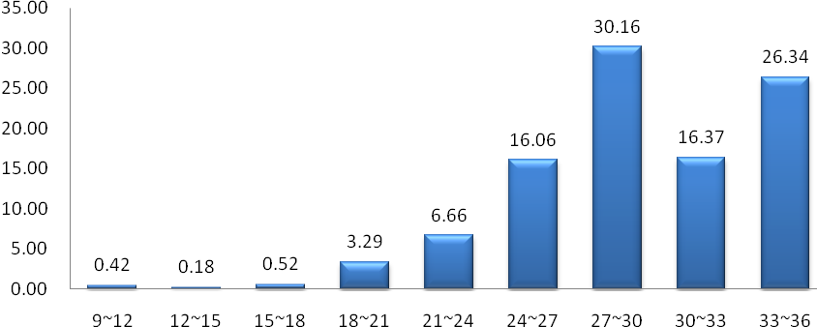
Figure 1 Political trust in transition China (percent, %)
Although only several studies have conducted quantitative measure on political trust in transition China, almost all the results indicate Chinese have high political trust (Shi Tianjian, 2001; Ma Deyong, 2007). Figure 1 show the distribution of political trust. Generally, the level of political trust is very high, most people (72.84%) have a political trust scores higher than 27 and only few (1.12%) respondents report scores lower than 18.
Independent variables
There’re two categories of independent variables: control variables and explanatory variables. Control variables include demographic factors (age and sex), socio-economic factors (education, income and migrant population), political interest, social trust, happiness…………………………………………………………………………………………………
……………………………………………………………………………………………………………

Table 1 Citizens assessment on government governance in transition China (percent, %)
 | Very good | Rather good | Not good | Not good at all
Economy performance | 31.20 | 60.23 | 7.89 | 0.68
Economy expectation | 80.50 | 15.07 | 3.60 | 0.84
Welfare performance | 20.91 | 55.98 | 20.13 | 2.98
Welfare expectation | 17.10 | 63.11 | 18.96 | 0.84
Public performance | 11.31 | 54.15 | 27.73 | 6.81
Public expectation | 14.52 | 71.46 | 27.55 | 0.99

Similarly to political trust, Chinese citizens’ assessment to government governance is relatively high. Table 1 indicates Chinese citizens’ retrospective and prospective assessment to three kinds of government governance. Citizens report lower scores on retrospective assessment than prospective assessment, which suggests citizens have optimistic attitude on the socio-economic development in the future.
Specifically, no matter retrospective or prospective assessment, citizens report the highest score on economic development, 91.43% of them satisfied with current economic development and 95.57% of them having confidence on China’s future economic development; followed by social welfare, 76.89% of them satisfied with the current status, and 80.21% believing there will be improvement on social welfare in the future five years; finally pure public goods supply, 85.98% of the citizens agree government will achieve improvement on the supply of such pure public goods………………………………………………………………………………………………………
…………………………………………………………………………………………………………….
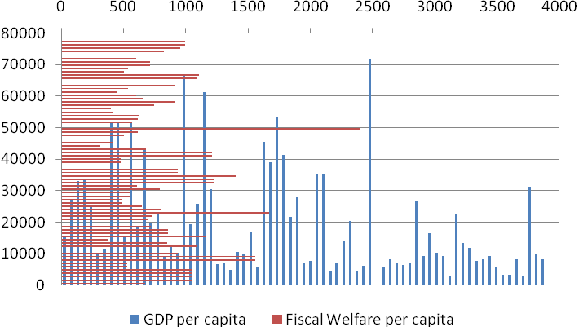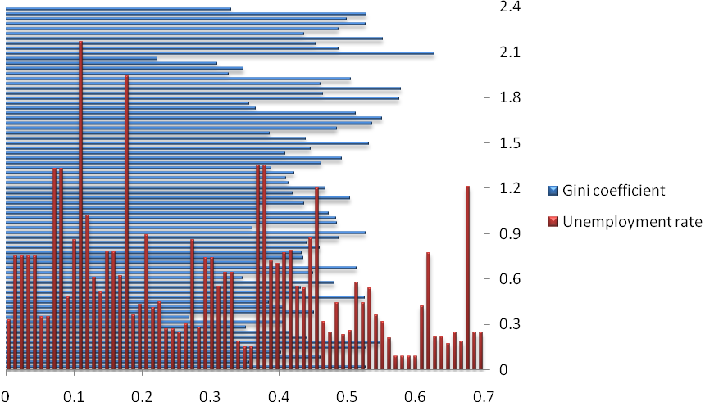
Figure 2 GDP per capita in 73 sample counties Figure 3 Unemployment rate and Gini coefficient in 73 sample counties

Unemployment rate (Unemp): the percentage of unemployment population in 2007;
Gini coefficient (Gini): Gini coefficient is calculated from individual level data;
Unemployment rate and Gini coefficient are another two important indexes to assess the level of local governance. Figure 3 displays the distribution of unemployment rate and Gini coefficient in 73 counties. Unemployment rates are generally low, 50.68% counties with rate lower than 0.5% and only 12.33% with rate higher than 1%; however, the Gini coefficients are higher. There are 55 counties (75.34%) with Gini higher than 0.4 and even 16 counties (21.92%) with Gini higher than 0.5.

3.3 Model
Generally speaking, there are two main methods to explore the relationship between government performance and political trust: (1) research the relationship between country’s history governance performance and political trust utilizing time series data; (2) research the relationship between subjective assessment to governance performance at individual level and political trust using the cross-section data. However, both of them do not deal with methodology problem appropriately. The first one neglects citizen, who is the subject of political trust; the second one replaces objective governance performance with subjective assessment and thus confuses government governance itself and citizens’ assessment. Based on these reasons, subjective assessment to governance performance at individual level and objective governance performance at county level will be analyzed at the same time in this paper……………………………………………………………….

4 Subjective governance assessment and political trust in individual level
As an exploratory study, this paper firstly utilizes OLS model to fit the data in individual level. This model treat age, sex, education, income, migrant, social trust, political interest and sense of happiness as control variables, and set up retrospective/prospective assessment of economic development, retrospective/prospective assessment of social welfare and retrospective/prospective assessment of pure public good supply as explanatory variables. Table 2 shows the result of OLS.

5 Objective government governance and political trust
Only the effect of subjective assessment of governance performance on political trust cannot verify the hypothesis that government governance has an effect on political trust. Governance, a kind of government activities for the purpose to fulfill some policy aim, and its performance can be measured by a series of objective index, is objective itself. It’s In fact, limited by information and economic rationality, citizens are usually not able to reach precise and uniform judge for objective governance. Even so citizens’ assessments are still an important measurement for governance performance, just not equal to the objective government governance…………………………………

6 Conclusion
The statistical model at individual level shows, citizens’ positive retrospective and prospective assessments on economic development, social welfare and pure public goods supply, significantly promote the level of political trust. Besides, there are two notable points as following: (1) at the individual level, the influences of retrospective assessments are generally stronger than prospective assessment, which suggests Chinese citizens are rational in this issue as when they express political support for the government, they pay more attention on government’s past performance; (2) no matter retrospective or prospective assessment, pure public goods supply has the strongest power on political trust, the less one is economic development, and the least one is social welfare. This result doesn’t accord with the results foreign researchers find in advanced industrial countries and post communist countries. This probably results from the unique situation in transition China: huge economic development has happened in transition China, but the pure public goods supply, such as public safety, environment protection and institution construction, still relatively lag far behind………………………
…………………………………………………………………………………………………………….

References
[1] Almond G.A and Verba S. The Civic Culture: political Attitudes and Democracy in Five Nations, Princeton, NJ [M]. Princeton University Press, 1963
[2] Easton, D. A Systems Analysis of Political Life. New York: John Wiley and Sons, 1965
[3] Lane, R E .Political Life [M]. New York: Free Press, 1959: 164
[4] Putnam, R.D.. Tuning In, Tuning Out: The Strange Disappearance of Social Capital in America. Political Science Review, 1995(28):664-683
[5] Easton, D. A Reassessment of the Concept of Political Support [J]. British Journal of Political Science, 1975(5): 435-457
[6] Kenneth Newton and Pippa Norris. Confidence in Public Institutions: Faith, Culture, or Performance? In Susan, J. Rharr and Robert, D. Putnam, Disaffected Democracies, Princeton [M]. NJ: Princeton University Press, 1997: 52-73
[7] Mishler, W. and Rose, R. What are the origins of Political Trust? Testing Institutional and Cultural Theories in Post-communist Societies. Comparative Political Studies, Beverly Hills: Feb 2001(34): 30-62
[8] Newton, K.. Trust, Social Capital, Civil Society and Democracy. International Political Science Review, 2001(22): 201-214
[9] Inglehart, R.. Postmateralist Values and the Erosion of Institutional Authority. In Nye, J.S, Zelikow, P.P and King, D.D.Eds, Why People Don't Trust Government [M]. London, England; Cambridge, Massachusetts: Harvard University Press, 1997: 217-236
[10] Shi Tian-jian. Cultural Values and Political Trust: A Comparison of the People’s Republic of China and Taiwan, Comparative Politics, Jul., 2001(33): 401-419
[11] Jacek Kochanowicz. Trust, Confidence, and Social Capital in Poland: A Historical Perspective. In Bo Rothestein Eds, Social Traps and the Problem of Trust [M]. Cambridge, UK: Cambridge University Press, 2005: 63-83
[12] Ma De-yong. Political Trust and Its Origins---the Comparative Study on Eight Countries and Regions in Asia. Comparative Economic and Social Institution, 2007: 83 (in Chinese)
[13] Citrin, J.. Comment: The Political Relevance of Trust in Government. American Political Science Review, 1974(68):973-988
[14] Hetherington, M.J. Why Trust Matters. Declining Political Trust and the Demise of American Liberalism. Princeton [M]. NJ: Princeton University Press, 2005
[15] Weatherford, M.S. Economic Stagflation and Public Support for the Political System [J]. British Journal of Political Science, 14:187-205
[16] Lawrence, R.Z.. Is It Really the Economy, Stupid? In Nye, J.S, Zelikow, P.P and King, D.D.Eds, Why People Don't Trust Government. London, England; Cambridge [M]. Massachusetts: Harvard University Press, 1997: 111-132
[17] Paul stoneman. This Thing Called Trust: Civic Society in Britain, Palgrave Macmillan, 2008: 69
[18] MacKuen, Michael, R. Erikson, and J. Stimson. Peasants or Bankers? The American Electorate and the U.S. Economy. The American Political Science Review, 1992(86): 597-611
[19] Clarke, Harold D., and Marianne C. Stewart. Economic Evaluations, Prime Ministerial Approval and Governing Party Support: Rival Models Reconsidered. British Journal of Political Science, Apr., 1995(25): 145-170
[20] Jenney Job. How is Trust in Government Created· It Begins at Home, but Ends in the Parliament [J]. Australian Review of Public Affairs, 2005, 6:1 - 23
[21] Henar Criado and Francisco Herreros. Political Support: Taking Into Account the Institutional Context, Comparative Political Studies, Beverly Hills: Dec 2007(40): 1511-1532
[22] Yang Pei-hong, Government Behavior and Trust: The Case of China [J]. Cato Journal, Fall 2007, 27, 3, ABI/INFORM Global: 359-372 (in Chinese)
[23] Stephen W. Raudenbush, Anthony S. Bryk. Guo Zhigang (translate). Hierarchical Linear Models Applications and Data Analysis Methods [M]. Peking: Peking Social Science Literature Press, 2007:6 (in Chinese)

对于基金资助请放在第一页的脚注处, 并统一用格式“Financed by +资助项目”。也请您翻译准确资助的项目名称。

